NORTHFIELD COMMUNITY PRESCHOOL, PRIMARY, and ELEMENTARY SCHOOL
2000 New Road
Northfield, New Jersey 08225
609.407.4005
www.ncs-nj.org

Mrs. Maureen Vaccaro
Principal
mvaccaro@ncs-nj.org

Dear Parents and Guardians –

For the safety and well-being of our students, parent and school Visitors and Volunteers have always been asked to attend a district Visitor and Volunteer training session. The objective of training the school Visitors and Volunteers is to assure that we are all clear and consistent on our procedures and goals for all Visitors and Volunteers spending any time in our school district around the children. The Visitor and Volunteer training is for anyone spending time in the school building, either in the classroom or attending classroom celebrations.

Again, anyone wishing to either Visit or Volunteer in our school must attend the Visitor and Volunteer training program, only ONCE during PreSchool through Grade 4, and then be approved by the Board of Education, before attempting a school visit.

ONLINE Training sessions meet.google.com/doy-bsux-sgp are scheduled throughout the school year. You do not need to pre-register. The sessions are as follows:

MONTH | DATE | TIME
SEPTEMBER | Tues. Sept. 10 (Back-To-School Night) | 6:35 p.m. Cafe
 | Wed. Sept. 11 (Back-To-School Night) | 6:35 p.m. Cafe
 | Thurs. Sept. 12 | 9:00 a.m.
 | Thurs. Sept. 12 | 3:30 p.m.
 | Thurs. Sept. 19 | 3:30 p.m.
 | Mon. Sept. 23 | 9:00 a.m.
 | Thurs. Sept. 26 | 3:30 p.m.
OCTOBER | Wed. Oct. 9 | 3:30 p.m.
 | Fri. Oct. 18 | 10:00 a.m.
NOVEMBER | Mon. Nov. 11 | 11:00 a.m.
DECEMBER | Mon. Dec 16 | 3:30 p.m.
JANUARY | Tues. Jan. 14 | 9:00 a.m.
FEBRUARY | Fri. Feb. 7 | 3:30 p.m.
MARCH | Thurs. March 13 | 3:30 p.m.
APRIL | Tues. April 15 | 9:00 a.m.
MAY | Thurs. May 8 | 1:00 p.m.

Respectfully,

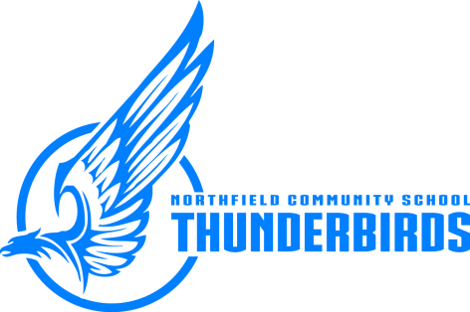
Mrs. Maureen Vaccaro
Mrs. Maureen Vaccaro
Principal

Northfield Community School – “Children First”
Equal Opportunity Employer

